External Help Document

1. Ensure the MoreMovieData.csv is loaded in the same folder and is in this format: 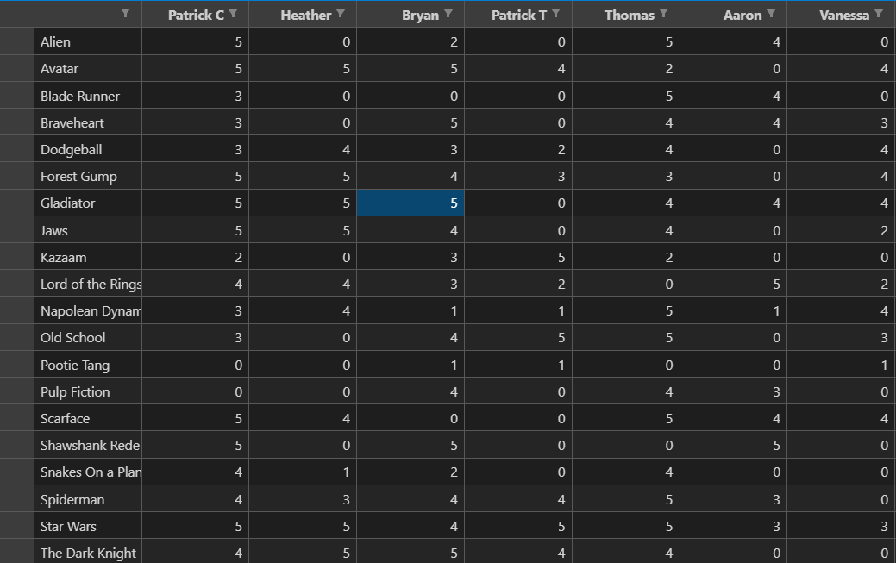
2. Greeted by movies, you can sort using different filters

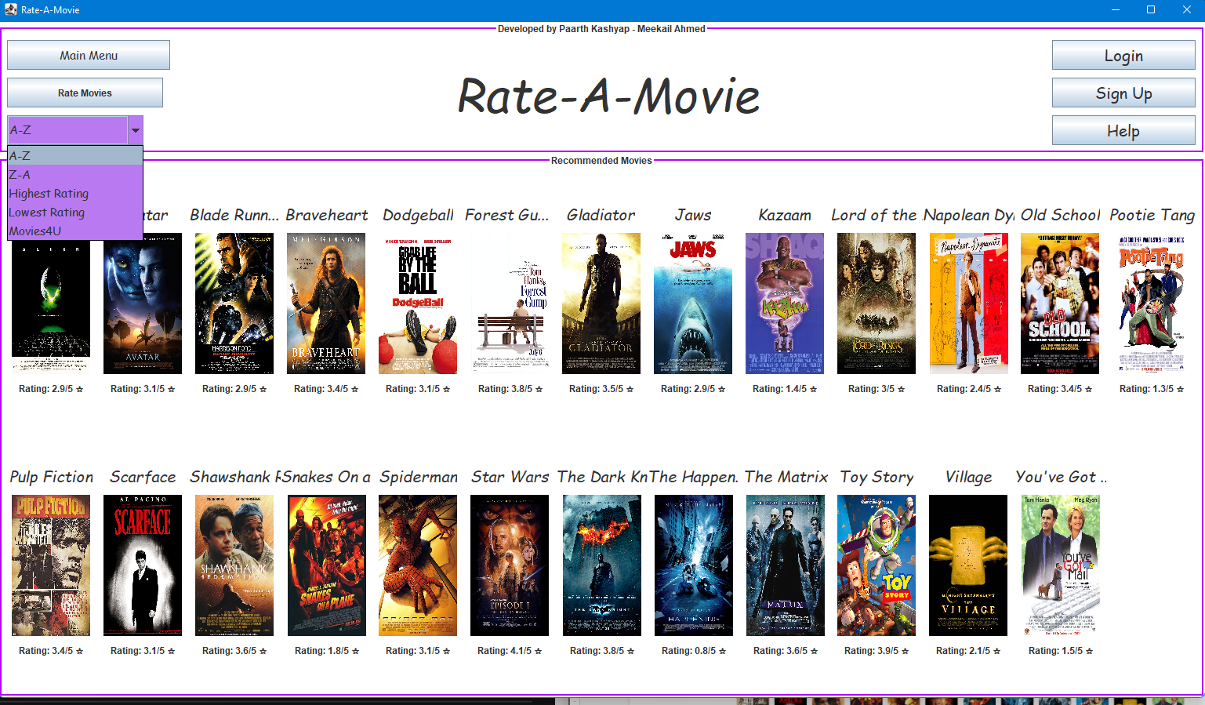

1. To Rate movies or access the Movies4U, create an account or login using default accounts



1. Enter information on Login and sign-up and proceed by clicking either sign-up or login
2. For Sign-up, click sign-up and then ok on the pop-up, Enter your information on the present screen and login

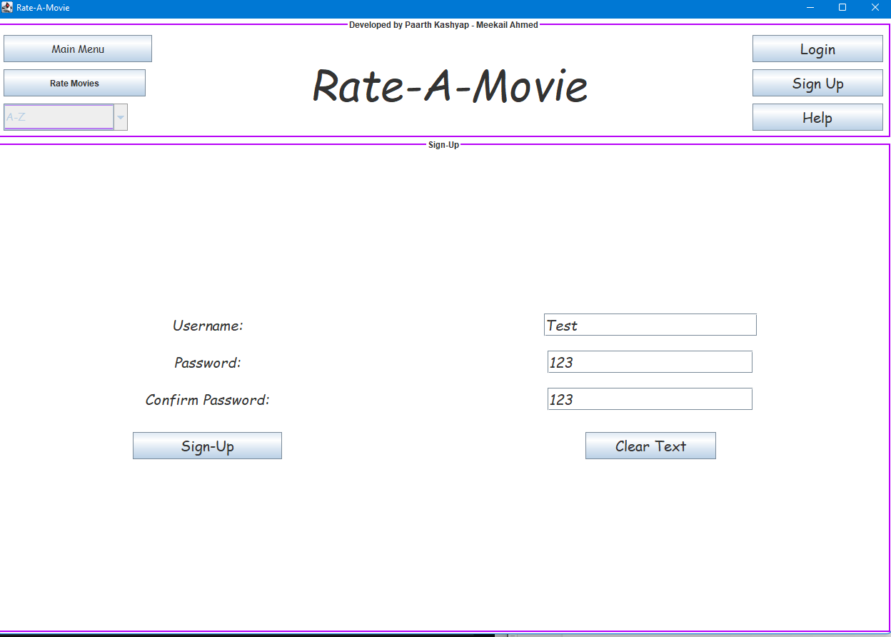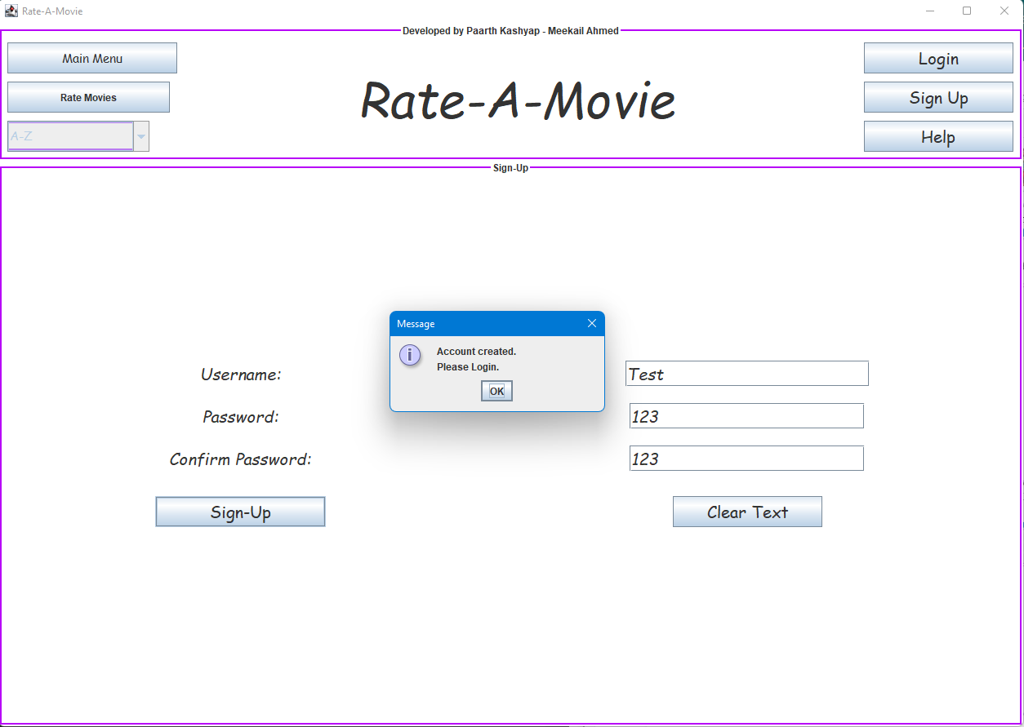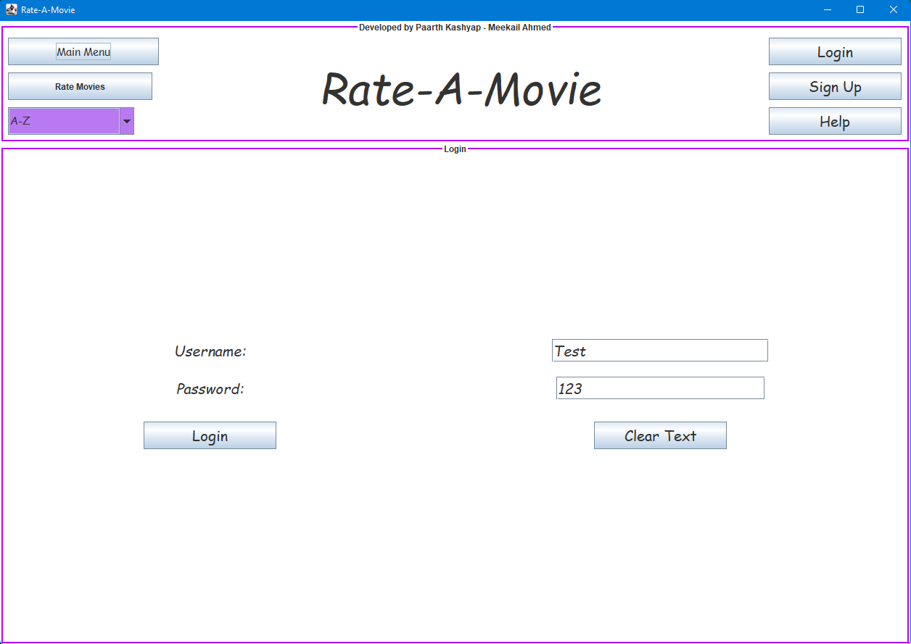 

If pop does not appear, the account has not been created and an error has occurred.

6B. 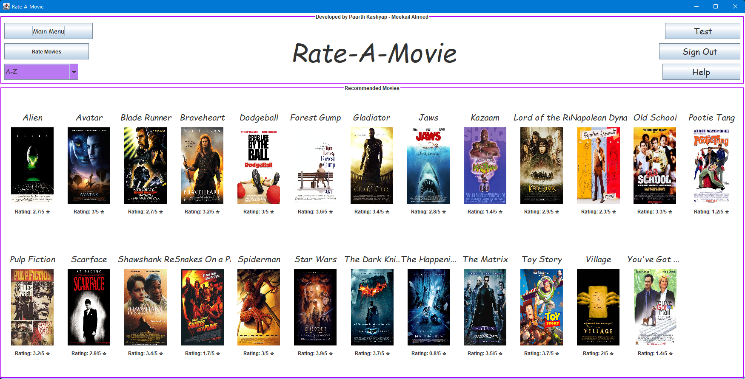

7. To rate movies, click on Rate Movies after logging in and selecting the movie and rating. The Text on the bottom refers to your current rating of the movie (0 means never rated).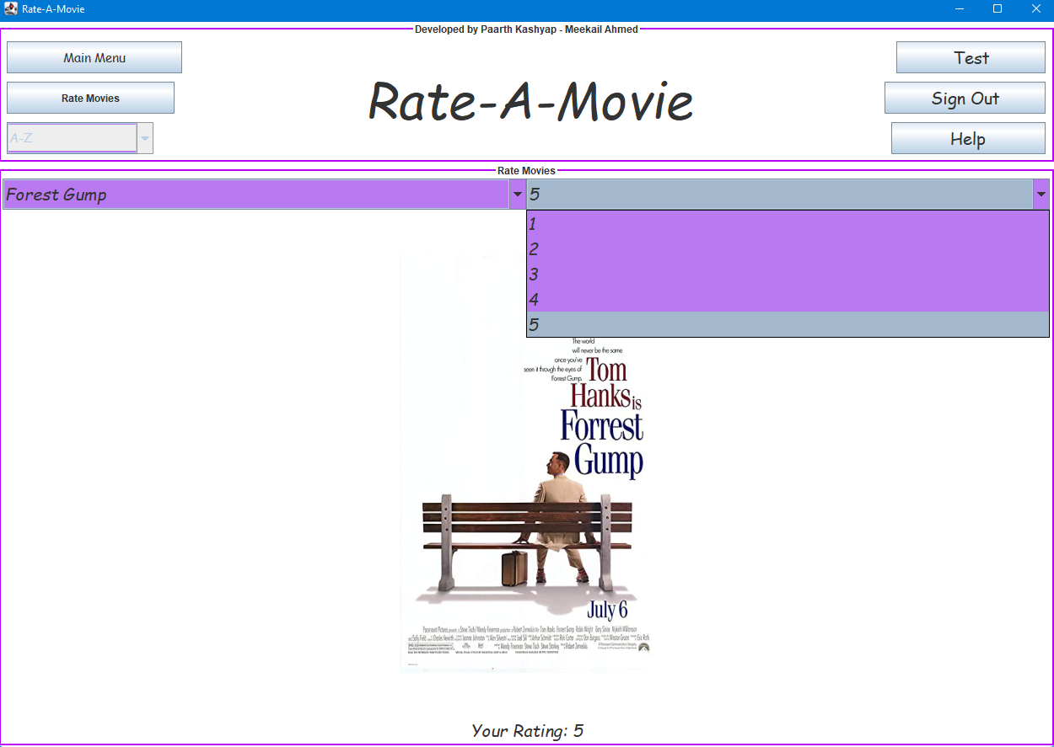

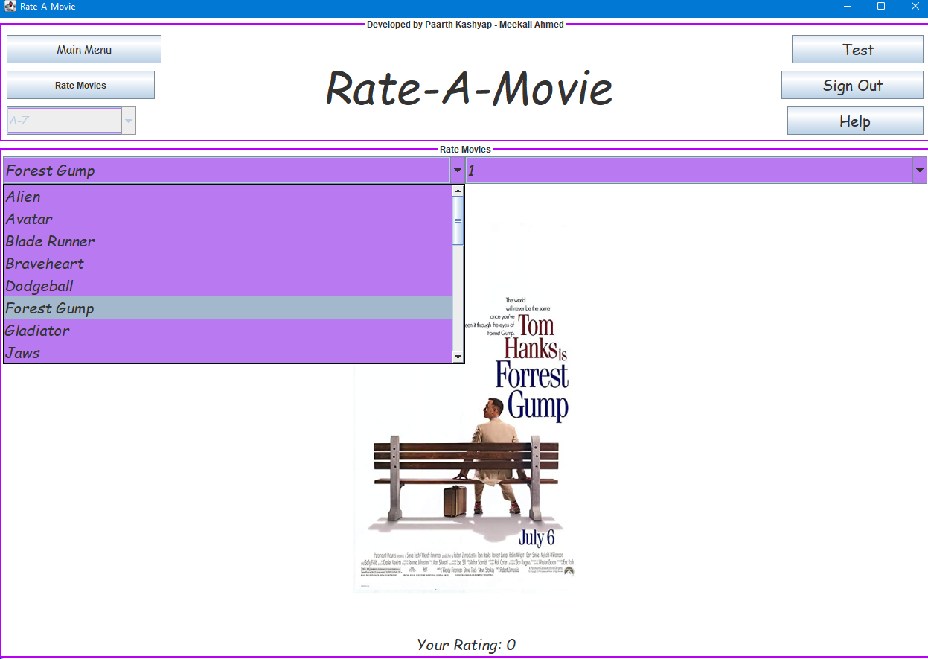

8. To return to Main Menu, click on the main menu button (top left)

9. Viewing your recommendations, click on the filter Movies4U from the main page

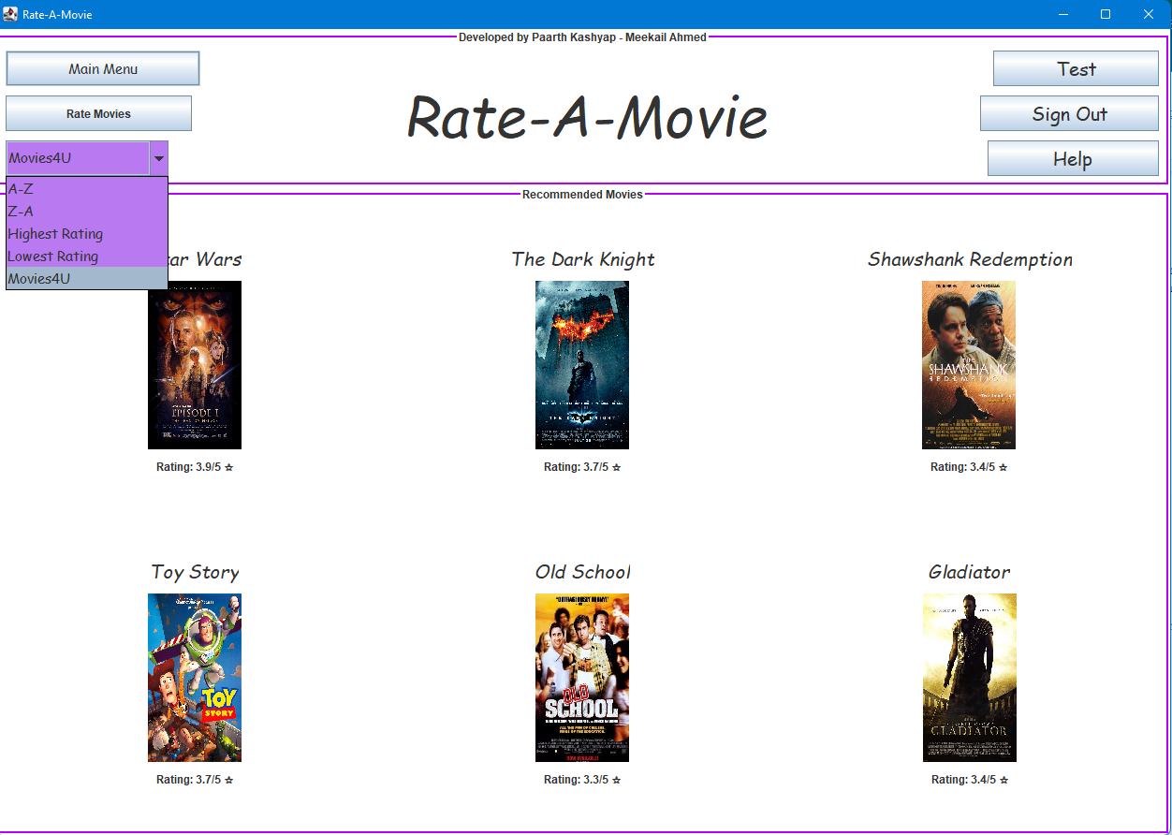

10. To close the program, click X on the window (top right).

Testing Notes

* You can only view recommendations and rate movies After logging in. Otherwise, a message will pop up prompting you to log in.
* If a new user is created, the default recommendations movies are unwatched movies in decreasing order based on the average rating (5 stars to lower)
* The recommendation movies filter is inside the main filter (purple sort feature in the header)
* The Rating Movies panel will display a rating of 0 if a movie has never been rated before. Rating update as a new rating is given.
* Signing out returns you back to the main page with all movies
* The help button is a short description of this document
* To see files update in real-time, log in and open the CSV and txt files on replit. Update reviews on Rate movies and assess the changes
* Adding new users add the user to CSV file along with adding a 0 for all unwatched movies at the end of the CSV File